CN Lab-3

Abdullah
24k-0859
BCS-5H

Task 1:
Server Code:
import socket
import json
import os

FILENAME = "calculations.json"

def calculate(num1, operation, num2):
if operation == '+':
return num1 + num2
elif operation == '-':
return num1 - num2
elif operation == '*':
return num1 * num2
elif operation == '/':
if num2 == 0:
return "Error: Division by zero"
return num1 / num2
else:
return "Error: Invalid operation"

def save_to_file(num1, operation, num2, result):
# Load existing records if the file already exists
if os.path.exists(FILENAME):
with open(FILENAME, 'r') as f:
records = json.load(f)
else:
records = []

# Add the new record
records.append({
"num1": num1,
"operation": operation,
"num2": num2,
"result": result
})

# Save the whole list back
with open(FILENAME, 'w') as f:
json.dump(records, f, indent=4)

server_socket = socket.socket()
server_socket.bind(('localhost', 9999))
server_socket.listen(5)
print("Server is listening, waiting for a connection...")

while True:
client_socket, addr = server_socket.accept()
print(f"Got connection from {addr}")
data = client_socket.recv(1024).decode()
print(f"Received: {data}")

num1, operation, num2 = data.split(',')
num1 = float(num1)
num2 = float(num2)

result = calculate(num1, operation, num2)
save_to_file(num1, operation, num2, result)

client_socket.send(str(result).encode())
client_socket.close()

Client Code:
import socket

client_socket = socket.socket()
client_socket.connect(('localhost', 9999))

num1 = input("Enter first number: ")
operation = input("Enter operation (+, -, *, /): ")
num2 = input("Enter second number: ")

message = f"{num1},{operation},{num2}"
client_socket.send(message.encode())

result = client_socket.recv(1024).decode()
print(f"Result: {result}")
client_socket.close()
Output:
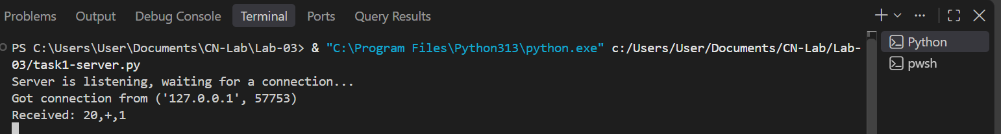
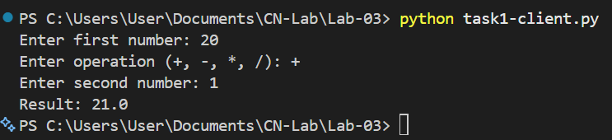

Task 2:
Server Code:
import socket

def get_grade(gp):
scheme = [
(4.33, "A+", "Excellent"),
(4.00, "A", "Excellent"),
(3.66, "A-", "Very good"),
(3.33, "B+", "Very good"),
(3.00, "B", "Very good"),
(2.66, "B-", "Good"),
(2.33, "C+", "Good"),
(2.00, "C", "Good"),
(1.66, "C-", "Passable"),
(1.33, "D+", "Passable"),
(1.00, "D", "Passable"),
(0.00, "E", "Failure"),
]
for point, letter, qualification in scheme:
if gp >= point:
return letter, qualification
return "E", "Failure"

s = socket.socket()
s.bind(('localhost', 9999))
s.listen(5)
print("Server started, waiting for connection...")

while True:
c, addr = s.accept()
print("Got connection from", addr)

data = c.recv(1024).decode()
gp = float(data)

letter, qualification = get_grade(gp)
response = f"Grade Point {gp} -> Letter Grade: {letter}, Qualification: {qualification}"

c.send(response.encode())
c.close()

Client Code:
import socket
s = socket.socket()

s.connect(('localhost', 9999))
gp = input("Enter your grade point: ")
s.send(gp.encode())

result = s.recv(1024).decode()
print(result)
s.close()

Output:
